**Microservice Architecture:**

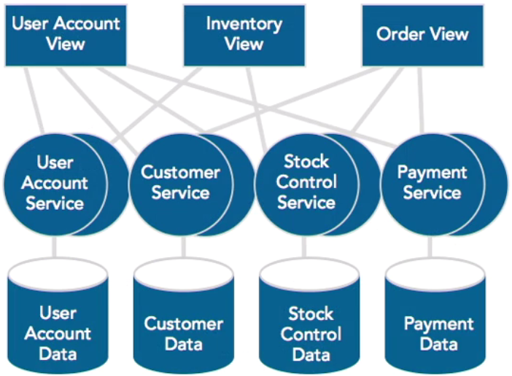

The microservices approach decomposes the monolithic application along the y-axis into services that satisfy single use case or set of related functionality. These services are